**Issues:** Hard disk Size is 0 MB – Unable to power on the VM.

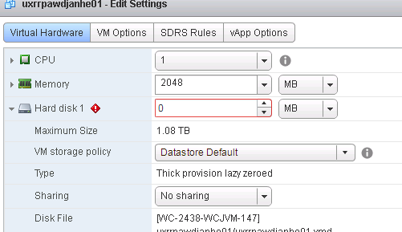

**Reason**: Disk Descriptor File has been removed.

**Fix**: Recreate the Disk Descriptor file.

Steps:

1. First login to the ESXi using Putty / Console.
2. Go the dataStore where the VM disk is sitting on.
3. Check for the disk file ( Flat-vmdk), If exists then we can create a new descriptor file.

# ls -l uxrrpawdjanhe01-flat.vmdk

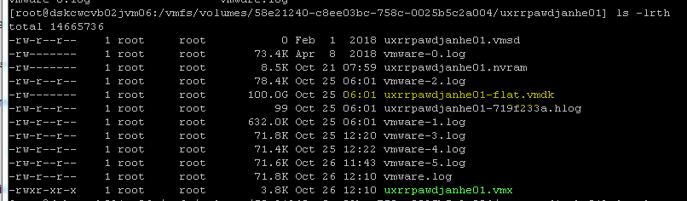

Check the size of existing flat.vmdk file.



1. Create new Disk:

*Command :*

*vmkfstool -c****size****-a****lsilogic****-d thin name* where:

* -c *size* - This is the size of virtual disk
* -a *virtual_controller (BusLogic, LSILogic, Paravirtual, or IDE)*
* -d *thin  - This creates the disk in thin-provisioned format (also zeroedthick , eagerzeroedthickoptions available)*

In our case we have Paravirtual SCSI adapter.

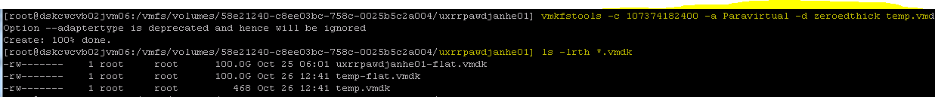

1. Rename temp.vmdk to the name that is required to match the orphaned .flat file (or uxrrpawdjanhe01.vmdk , in this example):  
     
   # mv -i temp.vmdk uxrrpawdjanhe01.vmdk
2. Edit the uxrrpawdjanhe01.VMDK file using vi editor.

* Use command "Shift + r" to enter replace mode.
* Locate and change the name of the .flat file to match the orphaned .flat, Press "Esc" to exit replace mode. Then Shift ZZ to exit

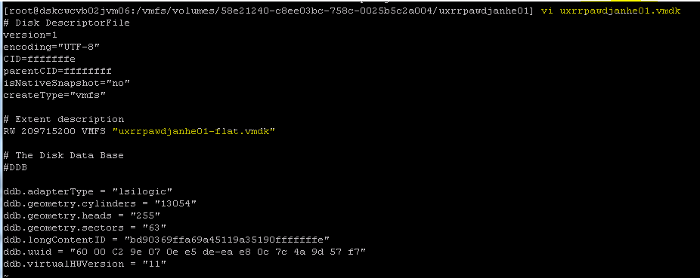

1. Power on the VM (do not Delete any Disk from VM edit Settings.)
2. VM will power on without any issues.
3. Delete the temp-flat.vmdk file created newly.

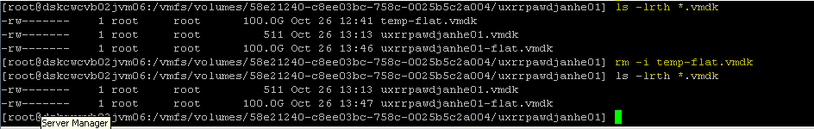

**Reference:**

[**https://kb.vmware.com/s/article/1002511**](https://kb.vmware.com/s/article/1002511)

[**https://www.settlersoman.com/how-to-recover-missing-vmx-and-vmdk-descriptor-file/**](https://www.settlersoman.com/how-to-recover-missing-vmx-and-vmdk-descriptor-file/)